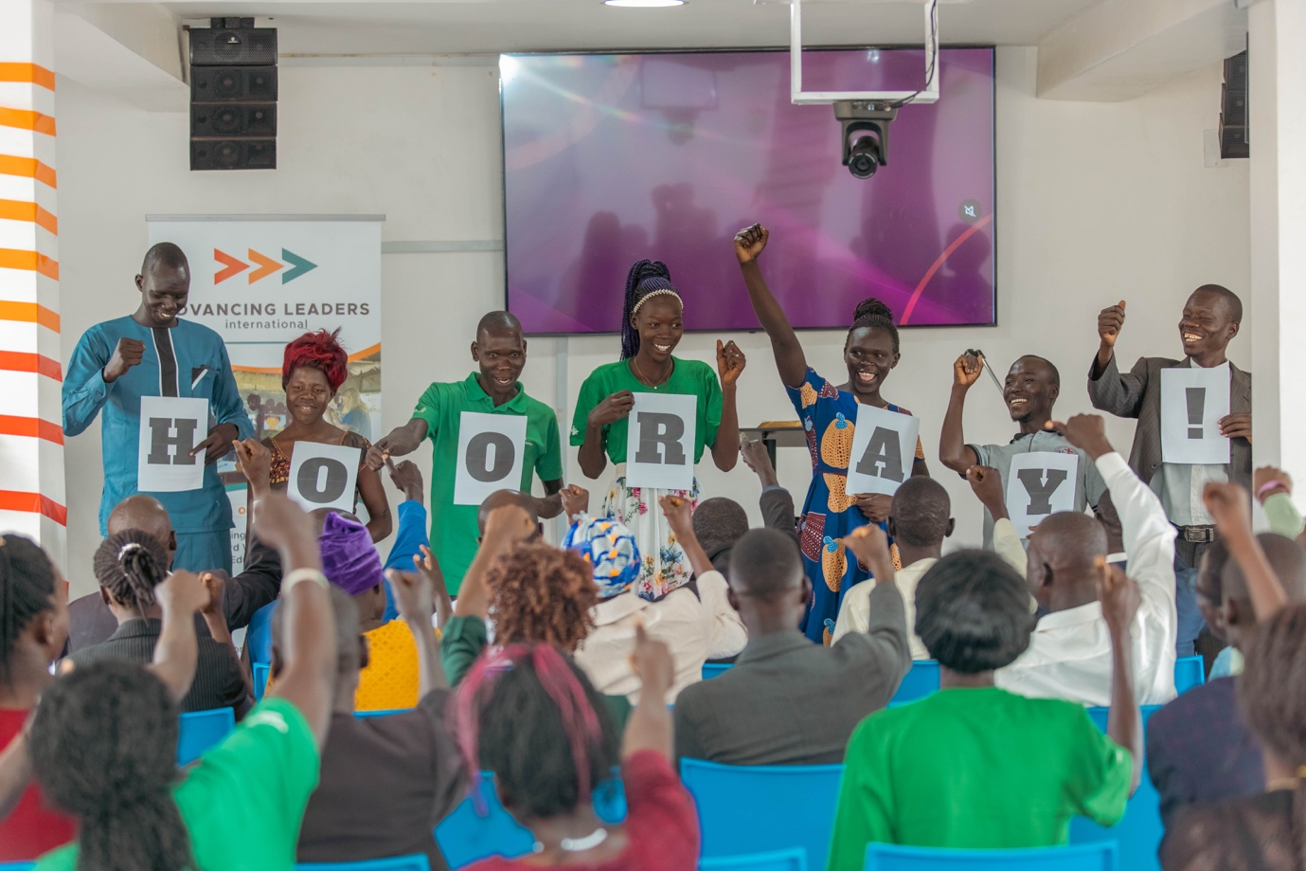

ADVANCING LEADERS INTERNATIONAL

UGANDA END OF YEAR REPORT |2023

Contents
Overview …………………………………………………... | Pg. 2
Royal Nursery and Primary School …………….. | Pg. 3
New Life ECD Center …………………………………. | Pg. 7
Highlight ……………………………………………………. | Pg. 10
New Beginning African Children School …….. | Pg. 12
Our Impact ………………………………………………… | Pg. 14
Graduation ………………………………………………… | Pg. 19
Looking forward ………………………………………… | Pg. 21

OVERVIEW

The ALI team in Uganda has had a successful 2023, rounded up with a first ever graduation ceremony for teachers trained in the country.

In addition to our work with the teachers, ALI Uganda also officially started partnership with the Khayamandi Foundation. ALI Uganda now operates as Khayamandi’s education arm in Uganda, and as a legally registered organization in the country, the foundation gives ALI cover to operate freely in Uganda. Our partnership with Khayamandi has allowed us to approach big organizations and government bodies boldly, and we have started a conversation with Windle Trust International to build partnership with them in the refugee settlement.

The team also added a new staff member, bringing the staff total in Uganda to three.

This year, the team has worked to train and mentor teachers from three schools - two in Rhino Refugee Settlement, Arua, and one in Buikwe District. This report summaries the work with these three schools and our findings from our time in their communities.

OUR WORK WITH SCHOOLS

All the schools for this year are relatively newly established, and we realized that they would benefit from training and mentoring in foundational issues like strategic leadership and planning, deep lesson planning and assessment, meaningful school and class cultures e.g., goals in classrooms and sense of urgency in the school communities, and use of available resources to make learning more engaging for learners.

These topics have given the schools an opportunity to reflect deeply on the purpose of their work and how best to achieve their goals.

We have found teachers willing to do such work and very eager to learn more. It has been a pleasure working with these schools over the course of the year.

Royal Nursery and Primary School

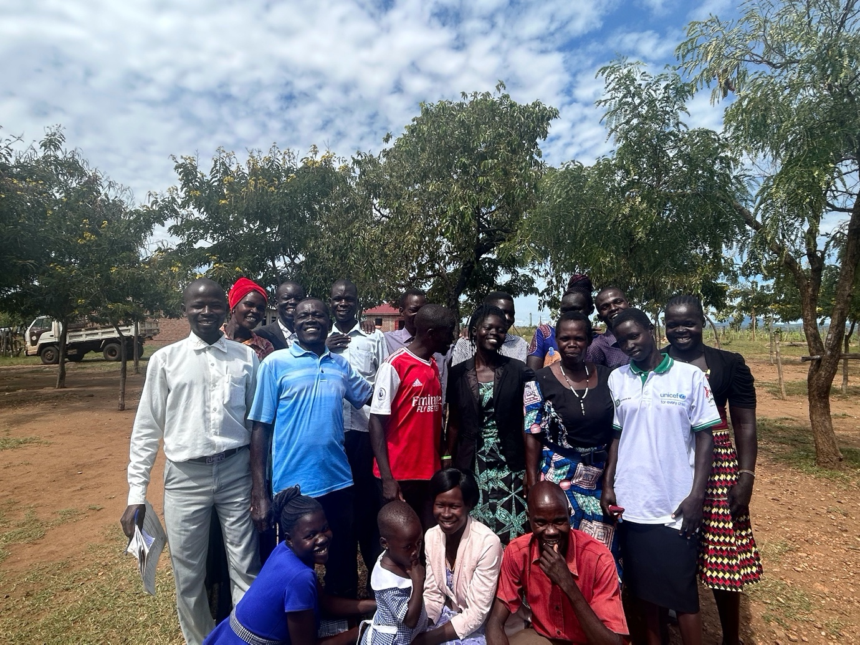

We have worked with Royal School since the early training days in 2018, and found that the school leadership nurtures an eagerness to learn and grow among the staff.

This year, we focused on the following topics:

January training | May workshop
- The child as the future  - Who are we as a school: Vision, Mission, Values + School Goals  - Setting class goals  - Making the most of our learning environment using learning aids  - Using learning centres to engage learners  - Reading  - Developing strong assessments | - Goal-driven classrooms  - Creating a sense of urgency  - Class management strategies  - Breakout sessions:  - Kindergarten - SMART goals for class and personal life  - Upper primary - going deeper on competences in the curriculum  - Leaders - work planning for the school

The staff turnover rate at Royal was very high this year, but we managed to work with three main categories of the Royal staff:
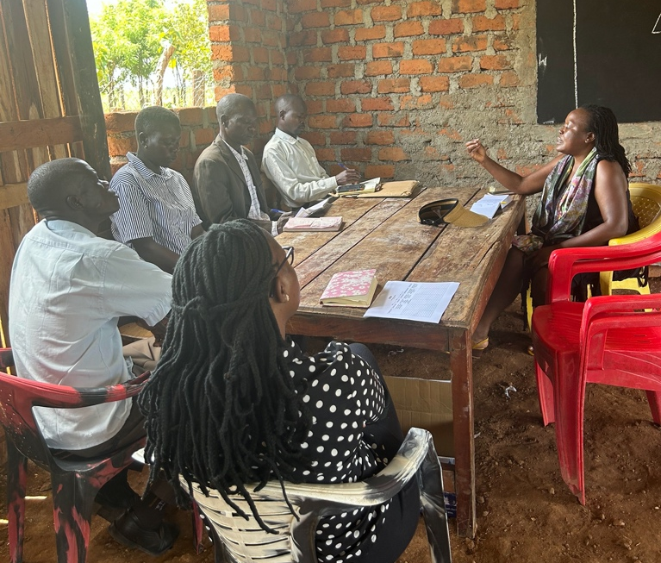
School leaders:
The school leaders - Head teacher, Deputy, and Director of Studies - had all received mentorship in the classroom and this year were pushed to consider how best to set structures for their school. They had an opportunity to share the school’s Vision, Mission and Values at our January training, and for the rest of the year were methodically guided on how to plan for the school around set goals. Though they had some challenges with accessing the work planning document via a laptop, they found it to be useful. The biggest highlight from this group is their willingness to ask each other questions and keep each other accountable. This sincerity has allowed them to engage with the content meaningfully. These leaders have also consistently attended ALI trainings, some of them since 2018, and they have developed a trust for ALI. We believe that their trust has allowed them to venture into new territory, learn new things and support their teams.

Lower primary:
At the start of the year, one P3 teacher approached us and requested that we observe his classroom. He was very eager and accepted support willingly. His class is one of the largest at Royal school, and he was supported to consider different classroom management strategies. We also worked with teachers from P1-P3 to develop schemes of work for the entire year. Using clear schemes of work, lessons could be developed to push students to deeper levels of learning. In this work, we found that the teachers were not scheming for the year enough in advance which was hindering the flow and progress of their lesson plans. We invited the leaders to consider how best to supervise and support the teachers in the classes, and shared a KPI document with them to offer suggestions on what to look out for in their supervision.

Kindergarten:
We opened 2023 with training on learning centers and shared lots of resources to enable the kindergarten section to develop more engaging lessons. However, at the start of the year, the team was seriously understaffed and had a hard time implementing the new ideas. We pivoted to assist them to set class procedures and practice engaging the children in interesting reading lessons. We worked with the teachers to develop SMART goals for themselves and for their classes. They enjoyed this opportunity and actually opened up about hopes to further their studies or engage in developments at their homes. We used this information to help teachers see how their work at the school could help them achieve even their personal goals. We wrapped up the year with a refresher on learning centers to ensure that the strongest teachers could run learning centers and teach others in the future.

The Royal School Library
Royal finally found a physical space for the school library, and a team was selected to help manage it. We trained the team on basic library procedures especially accessioning and lending procedures to enable them to manage the library stock effectively.
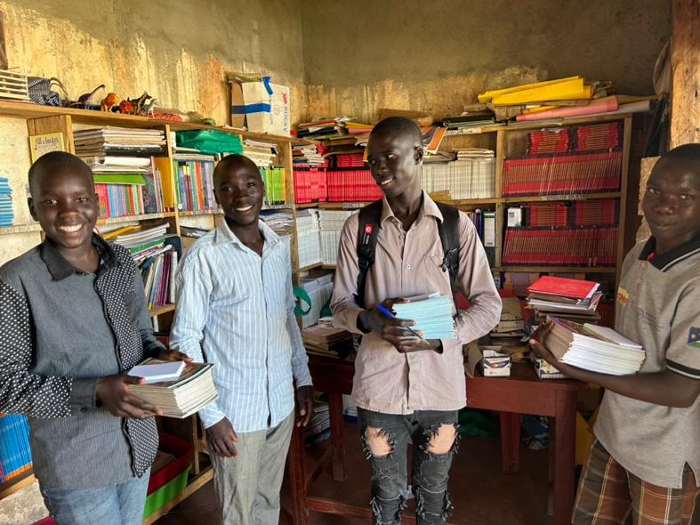
We were so glad to find students using the library, and found that the team was actually using the library systems to record the flow of library stock.

Unfortunately, the head library teacher left the school at the end of the year, but to our joy, he shared that he had trained a new staff member to replace him and take care of library management.

P7 Session
At Royal Primary School and at Hope Primary School, we conducted sessions with the P7 classes to encourage them that the world was open to them.

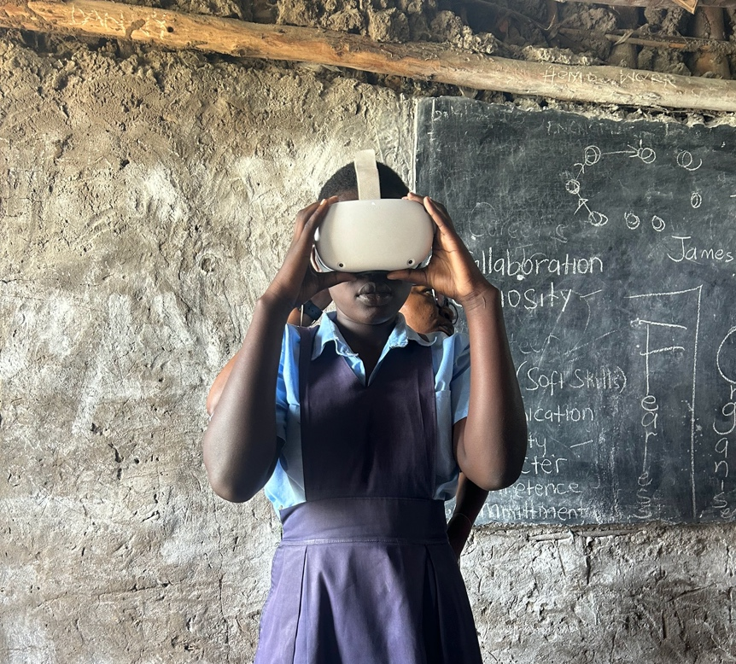

We invited South Sudanese university students to share stories of their life journeys with the classes. We also welcomed a young Tech Entrepreneur to share about the budding field of IT, and he conducted a VR experience for the learners.

We shared study tips with the P7 classes to offer them practical tips to manage the upcoming Primary Leaving Examination, and also shared thoughts on how to manage the self. We left each school with a copy of a career booklet showing pictures and descriptions of various career options and invited them to research and add their own.

The learners enjoyed the sessions, and many sought out opportunities to chat with the facilitators afterwards.

New Life ECD Center

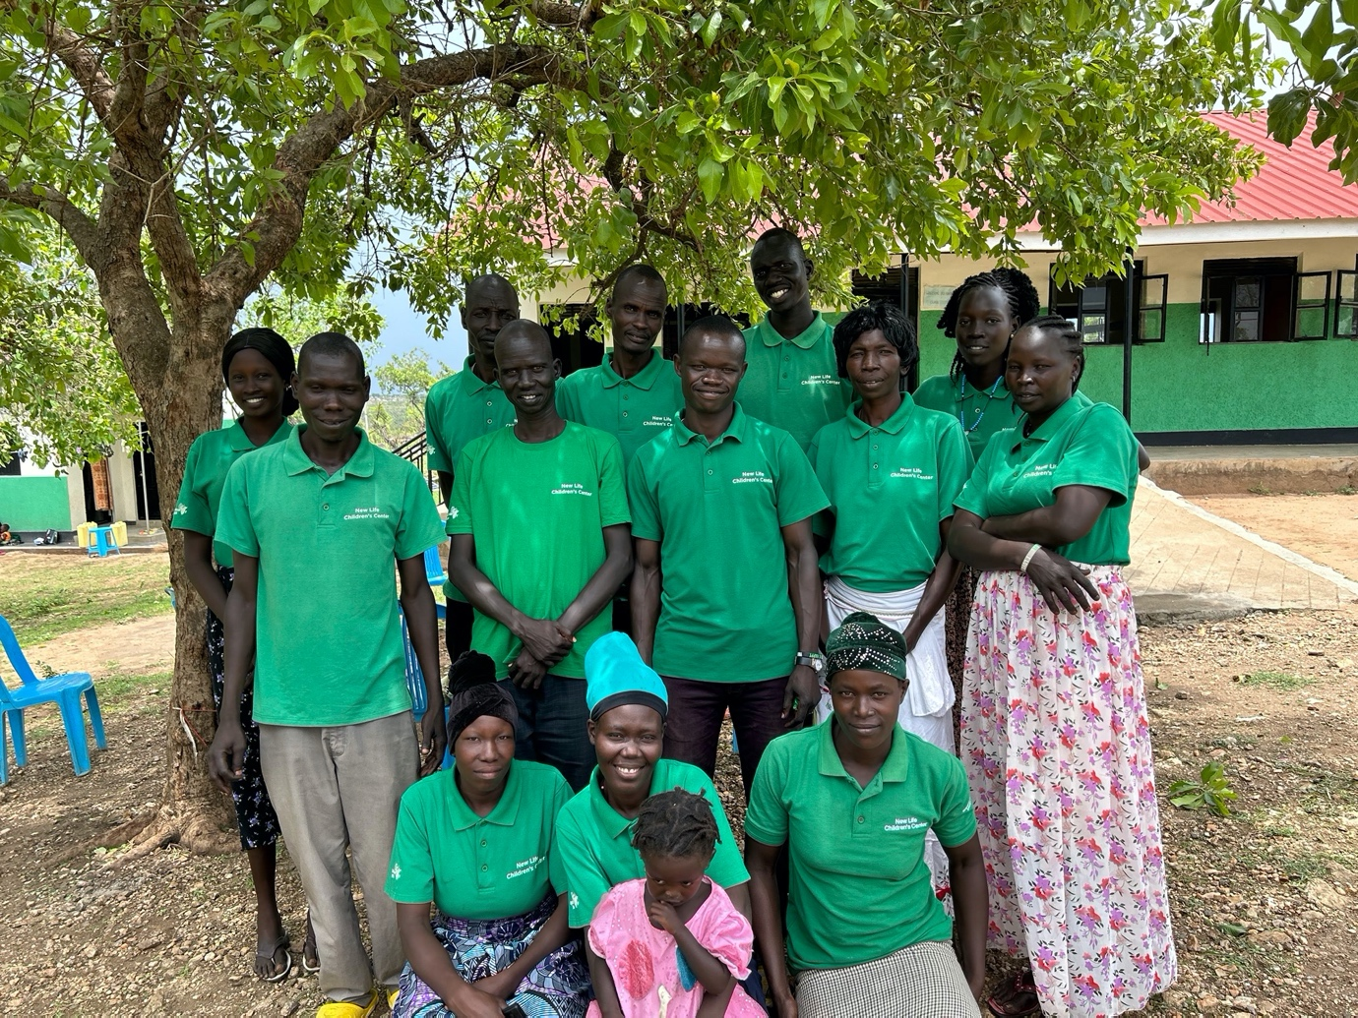

New Life Center has progressed so well since we started working with them at the end of 2021. When we first met them, the school was rather chaotic, classes were messy, and children were often crying from hunger or from fights in class and on the playground. In 2022, we worked to establish classroom procedures and also help the teachers to plan lessons consistently. This year, we focused on the following training topics:

January training | May workshop
- The child as the future  - Vision, Mission, Values, School Goals + Leadership structure  - Learning standards for each class level  - Deeper lesson planning  - Reading across the curriculum  - Making the most of our learning environment using learning aids  - Using learning centres to engage learners | - Goal-driven classrooms  - Teacher professional code of conduct  - Making the most of available resources to enhance lessons  - Foundations of assessment  - Creating a sense of urgency

Our mission for 2023 was to support the new head teacher to set roots in the school, and to push every member of the teaching team to see themselves as valuable and useful assets in the school community.

We started out the year by welcoming the leaders to share their vision with the staff and members of the PTA and Center Management Committee (CMC). The directors, Chris and Casey Willis, had a chance to share their heart for the school and encouraged the members present to send accurate messages into the community on behalf of the school. This helped to reduce the confusion surrounding the school’s operations and allowed the team to start the year on a more united front.

We introduced learning centers at New Life, and supported the team to practice center rotations and group activities until they were comfortable to run the centers on their own. Learning centers enabled the teachers to manage their classes of over 100 children much easier, and also helped to break up the monotony of the classroom. We had to conduct a second workshop in May to push the teachers to use the available resources more, and with the help of the head teacher, center rotations gave each teacher an opportunity to apply the resources with a smaller, more manageable group of children.

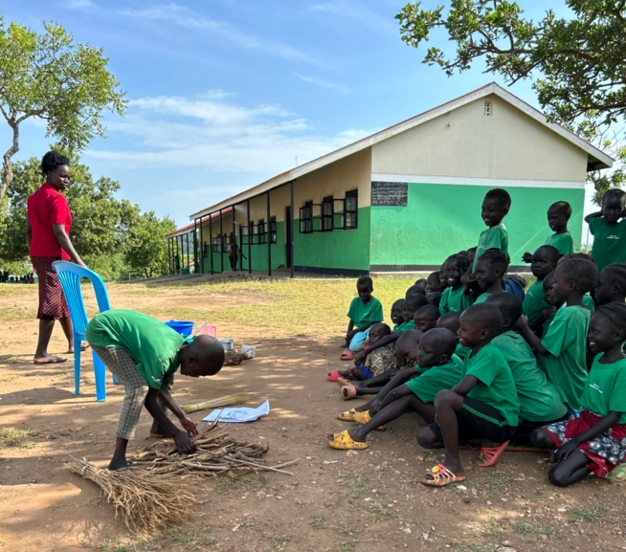 | 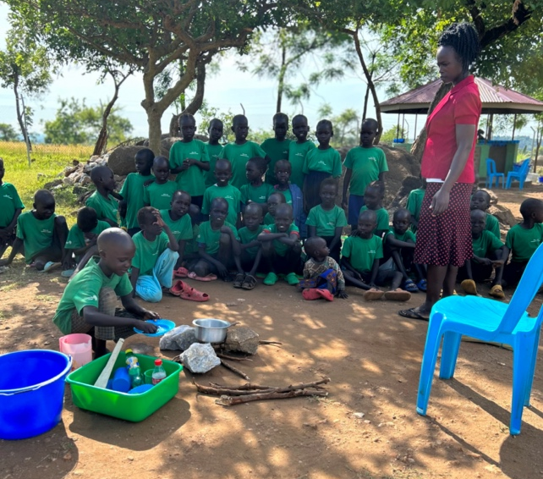
Tr. Maureen of top class conducting a center rotation where the children got to demonstrate
activities that they do at home. The child above is demonstrating how to prepare a meal using firewood.

We took time to guide teachers through the foundations of assessment and helped them think about the development of children in a more holistic manner. We shared that children need to develop in so many different areas particularly their cognitive skills, social skills, emotional management, and fine and gross motor skills, among others. We pushed them to think about assessment with this broader view and to support children to develop in all aspects.

Towards the end of the year, a promising teacher in baby class, shared that she was able to manage the children better and was now more sensitive to their emotional needs when handling outbursts in the classroom.
With all the good effort from the teachers, we noticed that they were struggling to scaffold lessons and help learners progress meaningfully in their learning. We shared with them a simplified scheme of work to help them see how they could build on topics throughout the year, and they applauded it as easier and more straightforward than what they were using before.

With the stronger scheme of work and the push for all teachers to participate in lesson planning and delivery, teachers stepped up in the classroom. Those who had been more laid back and disengaged now had structure to participate meaningfully, and with the push to lean in, they overcame their fear and started to practice teaching.

One even shared that he used to be so afraid to lead classes – sometimes the children would even correct him and laugh at him – but with repeated encouragement and support, he practiced courageously attempting to lead lessons with his students.

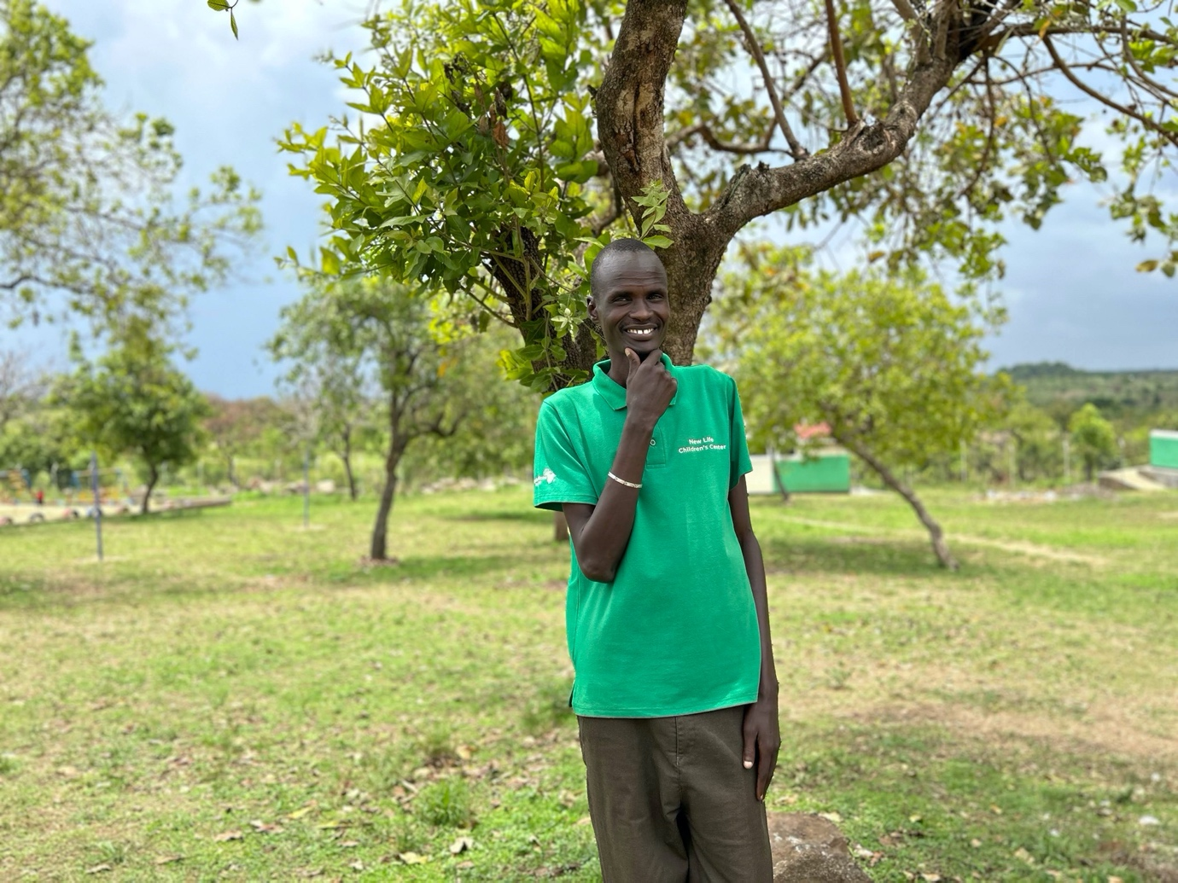
Tr. Nhial of top class.

HIGHLIGHT: The power of good leadership

When we first started our work with New Life ECD Center, the school was in such a chaotic state that any step in the right direction would immediately get undone. The leadership at the time was not strong enough to effect change. However, Chris and Casey offered a stable support system to enable our work to continue even while we were away – they would follow up with the teachers and even send screenshots of their lesson plans to us.

They then hired a new head teacher – Obet Cosmas – who took on the leadership of the school with a firm, yet gentle hand. Tr. Cosmas’ strong follow-through, along with Chris and Casey’s support magnified our efforts in the school.

It is a testament to the power of good leadership and also to the power of collaboration. We have seen New Life transform over the course of two years. Even the children seemed to bloom with the structure provided to them and would come up to us to say hello or to show us their skills on the playground.

Our work with New Life has made us value good leadership in a fresh way, and we believe that if we are to identify schools with strong leaders or strong and collaborative support systems, we would be able to have greater impact in schools for the good of the learners and their communities.

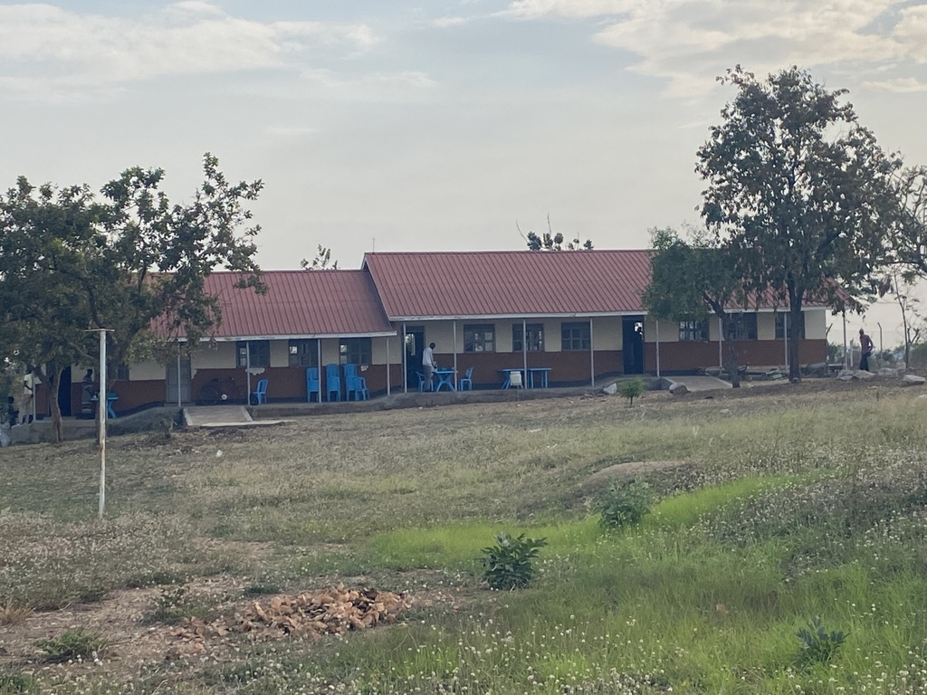
Before: the compound at New Life was a sign of the struggling leadership at the time.

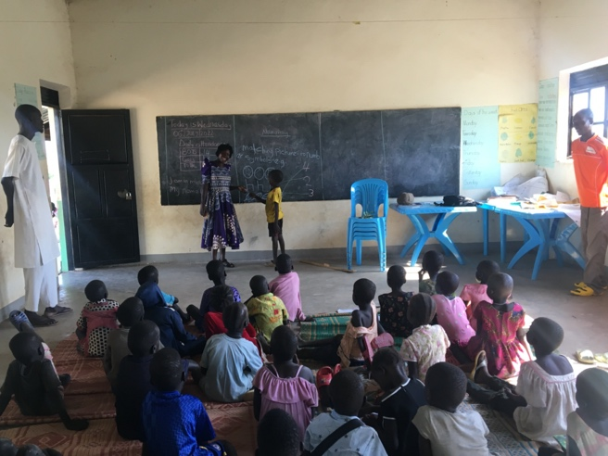 | 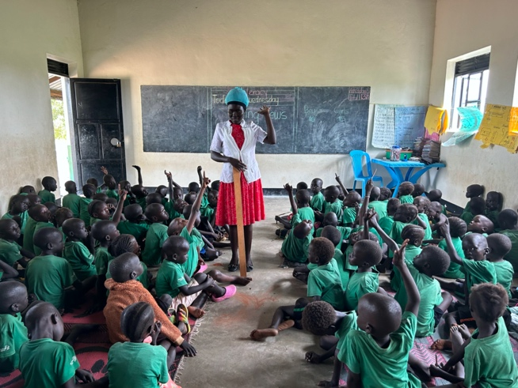
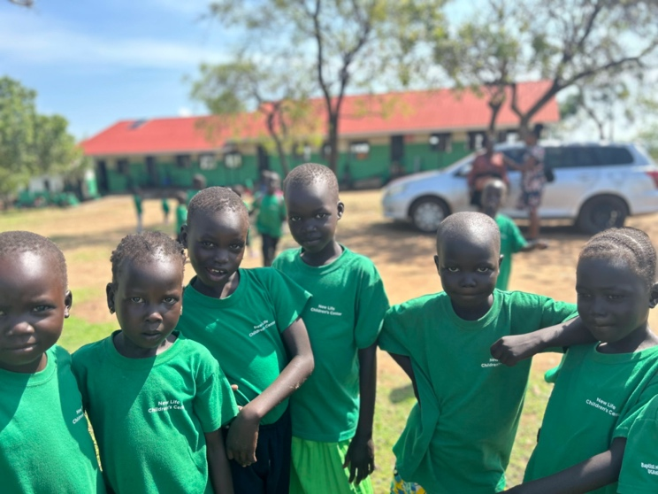

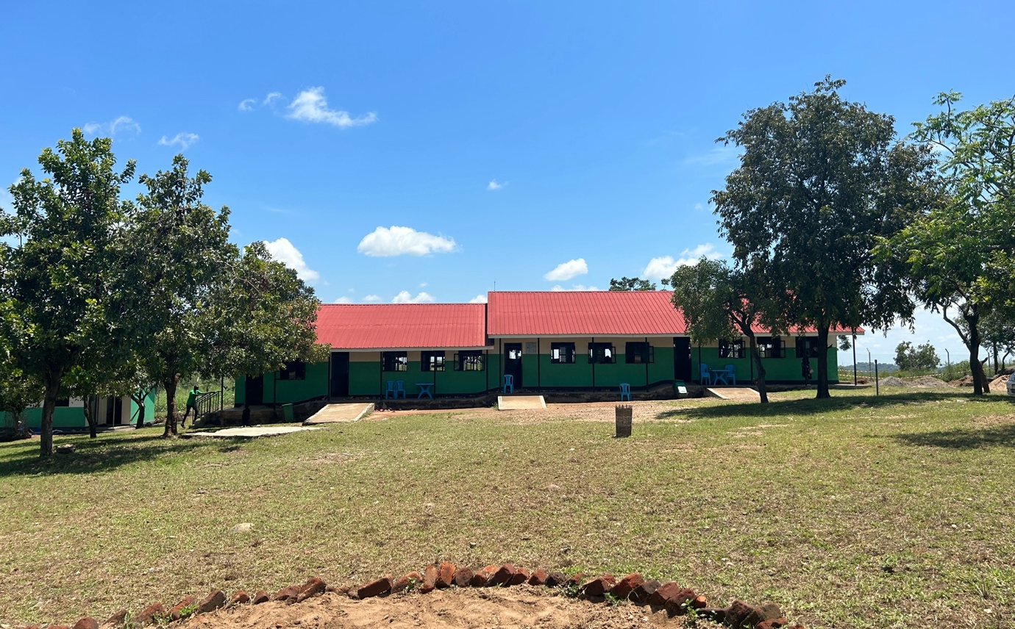
The power of good leadership – the leadership managed to get the community to participate in slashing the compound and made effort to beautify the buildings.
New Beginning African Children School

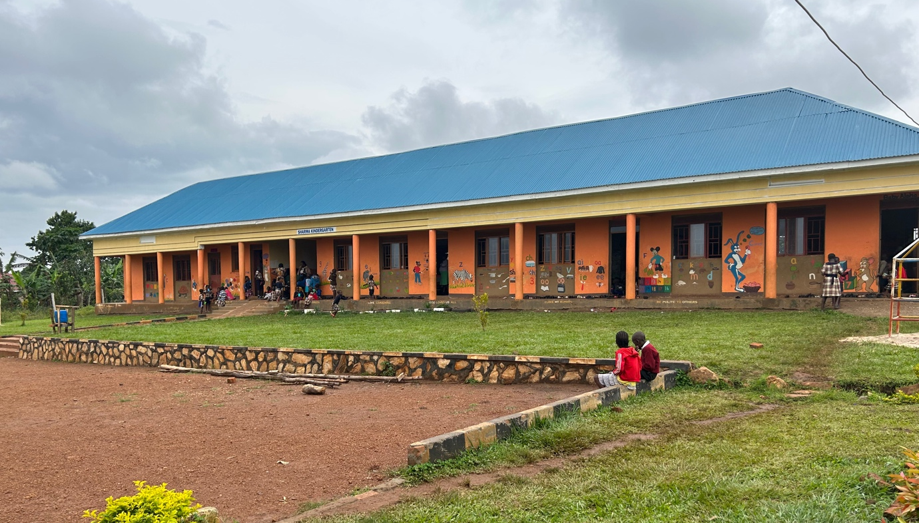

We started our work with New Beginning African Children School (NBACS) in 2022, but the team had a few problems and had such a high staff turnover rate that we had to pause and restart work with them this year.

In 2022, the school directors seemed eager to learn when we had meetings in person, but would then disappear or not be communicative. We worried that under such leadership, and with staff in flux, our efforts in the classroom would be undone. For 2023, we chose to work primarily with the school leadership in order to understand and refine their leadership style before going into the classrooms. We had the directors sign a new agreement with us with an understanding that our work together would require more clear communication, engagement and follow-through on their part.

For training topics at NBACS, we covered:

January training | May workshop
- Vision, Mission, Values + School Goals (for leaders)  - Leadership starts with me (for leaders)  - The child as the future  - Who are we as a school: Vision, Mission, Values + School Goals  - Fostering a positive school culture  - Positive discipline strategies | - Work plan and budget review for school leaders  - Monitoring performance on school goals for school leaders  - Effective communication for school leaders  - Goal-driven classrooms  - Creating a sense of urgency  - Using learning centres to engage learners

At the start of the year, we worked closely with the school leadership. Leaders invited to these sessions were the directors, the head teacher and the head of the kindergarten section, the staff member in charge of sponsorship, the school bursar and the school finance administrator. We gave these leaders a chance to sit together and evaluate the Vision, Mission, Values and goals that we had started to craft together in 2022, and then offered them an opportunity to share these with the whole school staff (teaching and non-teaching) at the January training. This training was very interesting because all the staff honored the invitation and seemed to resonate with the school’s overarching vision.

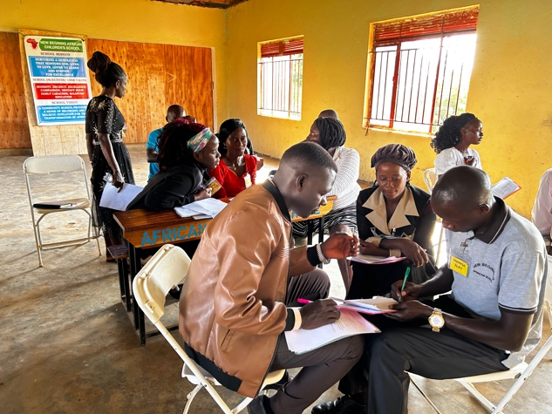 | 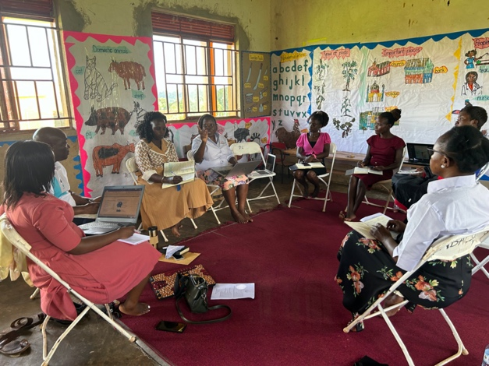

However, at our workshop in May, most of the staff seemed to have forgotten this vision - even though it was hanging up right at the entrance to the school. New Beginnings School perplexed us, and we had conversations with the directors about developing a friendly and respectful culture among the staff in order to encourage true engagement and ownership in the school community.

In the meantime, we continued to guide the leaders on how to create workplans based on the school’s overarching goals and how to budget and monitor performance towards these goals. The leaders appreciated these sessions and shared that it offered them more clarity and more agency in how to plan and budget for the school in the longer term. The bursar who was often the quietest at these sessions shared that the document allowed her to make more informed decisions on behalf of the school.

We took time to observe goings-on in the classes and would report back to the leadership team. In this process, we found that they didn’t have much of a system to track teacher progress, and encouraged them to create folders for each teacher where vital information and reviews could be filed and referred to. We also shared with them our suggestions on what important KPIs to track as they supervised and supported the staff in their roles.

We have found the leadership to be more responsive and communicative this year, and we feel that we have more of an understanding of them and of their team to work more deeply with the teachers next year.

OUR IMPACT

As we prepared to graduate our first batch of ALI-trained teachers and select new schools for next year, we conducted a focus group and disseminated a survey to find out what impact ALI has had working with our schools and to understand the mechanisms by which the impact may have come about.

Leaders from Hope, Royal and New Life Center were invited to our focus group and they reminded us of the needs at these 3 initial schools. All the schools were recently established to serve the refugee communities. As a result, they had to welcome untrained staff to support with teaching the children. These staff needed training, and those trained also needed refreshment. The schools were in need of resources like curriculum books, story books, classroom supplies and materials. They also needed equipment and furniture. Though the needs were many, all the leaders present resoundingly agreed that ALI met the needs of their schools, especially in light of ALI’s niche of teacher training, mentoring and equipping.

We surveyed the teachers at Royal and at New Life ECD Center to understand more. The survey was given only to teachers who had gone through significant ALI trainings – 25 teachers total.

Major lessons learnt from ALI

The teachers shared a myriad of lessons learnt from our time together.

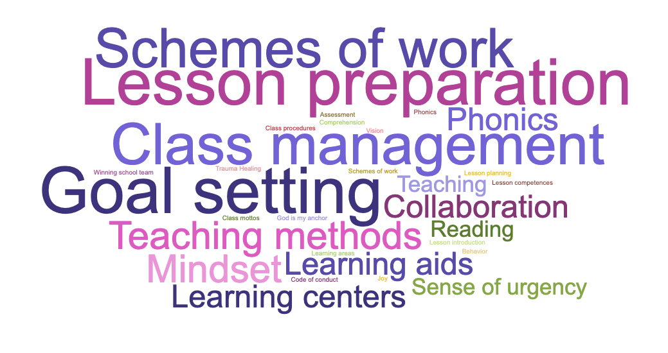

Teachers felt that they had gained skill and insight into how to scheme and plan lessons for the year. Coupled with that, classroom management was a big lesson especially for these schools with class sizes of over 100 children. Another big lesson for the teachers was goal-setting which we focused on heavily this year.

Understanding ALI’s impact

In our work with the teachers, we have trained, mentored teachers in classrooms, and provided resources, supplies and equipment for schools. We requested teachers to share what impact ALI has had in 4 main categories: Schemes of work and lesson planning, Student performance, on Individual teachers, and on School culture. Some of their responses have been included below.

- Schemes of work and Lesson planning
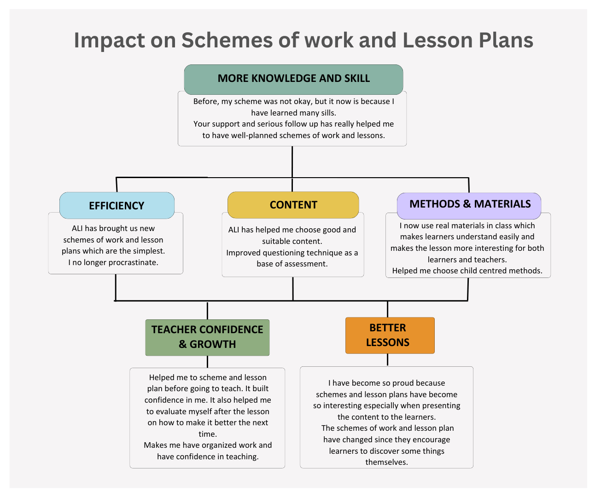

Teachers overwhelmingly felt that they had gained skill in scheming and lesson planning. Even those trained before ALI found the sessions to be useful, and one leader at the focus group session explained that some topics were skipped over in their school training. This knowledge and skill enabled teachers to be more efficient in their planning, to plan for deeper content and to employ varied methods and materials. These changes made teachers feel more confident and led to better lessons overall.

- Student performance
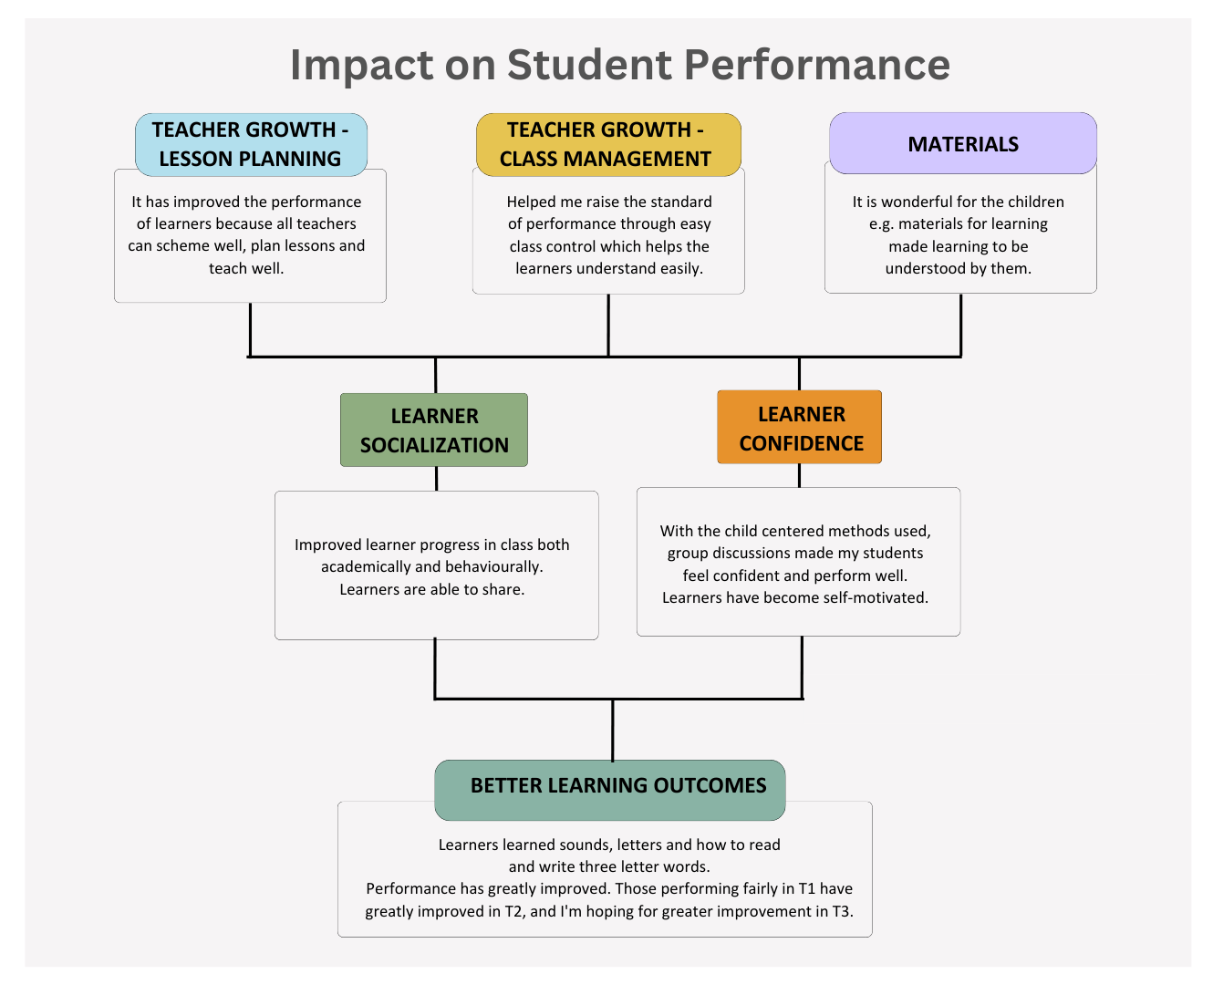
Teacher growth was in two main categories – lesson planning and classroom management. The two combined with access to materials and training on how to use them enabled learners to receive better socialization in their classrooms and built learner confidence.

In our class observations, we noticed that in classes with less skilled teachers, there was more fighting and disorganization in the classroom. However, as the teachers grew more skilled in their work, learners became more settled and ready to learn.

This in turn has led to better learning outcomes with teachers reporting improvements in student performance in the classroom. Even where teachers were able to identify more work to be done with the students, all the respondents largely felt that their students were performing better as a result of ALI’s work with them.

- The individual teacher
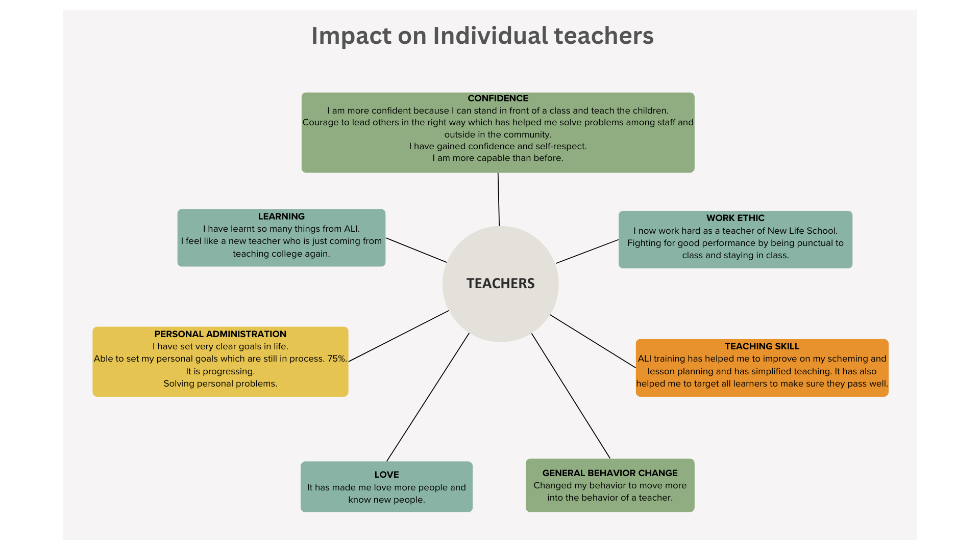

We asked the teachers to share what impact they felt ALI has had on them as individuals. One teacher shared that they have stayed the same, and two shared information that highlighted their personal dispositions independent of ALI.

All the others had lots to share about how ALI has influenced their personal lives. One effect that was well articulated was the confidence boost teachers experienced as a result of our work together but also likely as a result of their growing feeling of competence in the classroom. At New Life Center in particular, we were met with so many teachers who were idle in the first year, often shirking their class duties. However, with strong encouragement to see themselves as teachers and take on the work, those who have stepped up reported feeling good and were eager to continue to try developing their teaching skill in the future.

Teachers have also grown stronger in their personal administration and feel that they are able to set clear goals and solve personal problems.
We have seen teachers open up to aspects of training that are not immediately directly tied to teaching e.g., training on mindsets and on goal-setting, and they seem to enjoy it. One teacher shared that our trainings are holistic and care for the whole person. One of our favorite pieces of feedback from the teachers has been that these trainings are not just for the classroom, they are for life.
- School culture
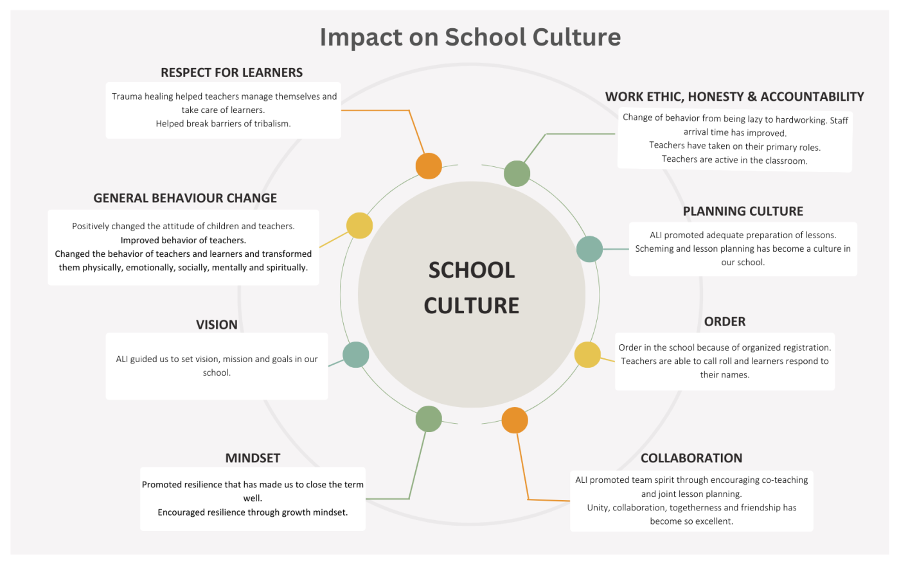

In responding to the prompt on how ALI has impacted their school culture, one school misunderstood and thought we asked what their school culture was. All the teachers discussed the question and came up with: working towards achieving the goals of the school through teamwork, resilience and trusting in what we do. It was not the answer we were hoping for, but we were glad to see their teamwork in action! We requested them to submit other responses, and from the new responses collected, we found that the respondents felt a change in their culture.

Teachers felt that planning had become a culture for them, and that they had grown in their ability to work collaboratively with one another. Teachers highlighted resilience as a disposition they now carry. They also shared that trauma healing sessions were particularly helpful in helping teachers manage themselves, support their students and break barriers of tribalism amongst themselves.

Surprising reach of the impact
In our focus group the leaders also shared some interesting effects of our work together.
- Two teachers present at the focus group shared that they stayed in the teaching profession longer than they had expected to because of ALI’s influence.
- Parents at New Life were willing to contribute slightly higher school fees having seen the changes at the school.
- Teachers have shared their lessons from trainings in job interviews in order to get a leg up, and it has worked for them!

Thankfully, we have seen a network growing among the different schools we have worked with, particularly Royal and New Life, and we believe that they will be able to support each other and continue the good work.

In fact, leaders at the focus group shared that to continue ALI’s impact. They intend to train incoming staff and will encourage co-planning and teaching amongst their staff. Leaders also plan to continue to encourage library use in their schools.

Impact mechanisms
At the focus group, we had a chance to ask why the leaders felt that ALI’s program works.
- Throughout the year, we have been reminded that ALI invests a significant amount of time at the schools, whereas other organizations drop in and out e.g., to collect data or to hold workshops. The teachers appreciate the time we pour into them, and we believe that it has helped us build common ground and trust at the schools.
- With regard to financial support, the leaders shared that they understand ALI’s scope and have found knowledge to be more valuable than financial handouts. For them, opportunities for training and support like what ALI provides are so rare that they appreciate what ALI brings to the table.
- The leaders also appreciate that ALI’s trainings go beyond solely classroom ideas and also touch on mindset and other topics.

Suggestions for ALI moving forward:
The leaders and the teachers shared some suggestions for us even as we move to new schools next year:
- For ALI to stay in touch – whether just stopping in to greet, or organizing a training once a year for all previous schools.
- For ALI to recruit teachers officially at schools to continue the work of mentoring and coaching the staff.
- For ALI to develop school clubs e.g., reading clubs at schools so that ALI’s presence can be felt even within the student body.

GRADUATION
On the 5th of December, 2023, ALI held its first ever graduation for ALI teachers in Uganda. We graduated teachers from 3 schools, 2 of which we had been working with ever since ALI’s work in Rhino Camp started in 2018!

Considering the growth of all the teachers, we wanted to celebrate their openness to learning, their commitment to teaching and their friendliness towards us.

We invited only teachers who had attended a significant portion of ALI trainings and who we had mentored in the classroom. We invited school directors, and community leaders such as PTA members and local council leaders. We also welcomed partners and friends in Arua town – Pastor Uche Izuora, and Mr. Herbert Niwahereza representing the Khayamandi foundation. We were extremely glad to have the Executive Director of ALI, Ms. Karin Knutson present in the country with us as well.

The day was a great celebration. Teachers spoke of how ALI impacted their lives and their school communities, and the friendship in the room was palpable. Each teacher received a certificate showing what they had grown or progressed in, and all teachers got goodies at the end of the day – some highly requested – such as ALI shirts and bags.

Graduation was a huge milestone for ALI. We are so thankful for the opportunity to work alongside the teachers in Arua and we trust that they will continue to train others. We left each teacher with a copy of an ALI handbook – bulleted lists of big ideas from topics we covered together – so that they can have the information easily accessible.

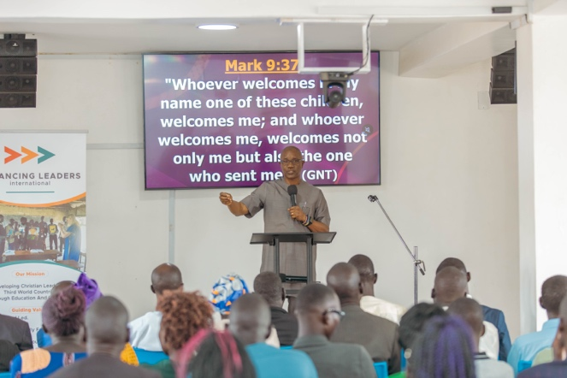 | 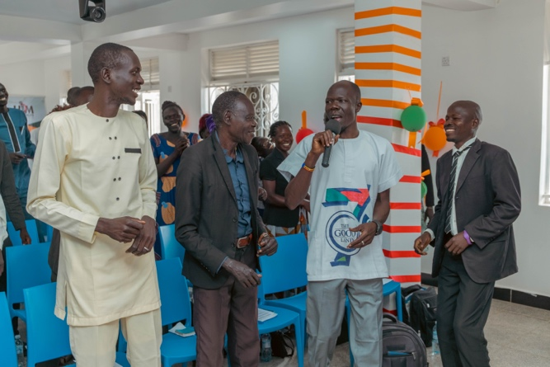
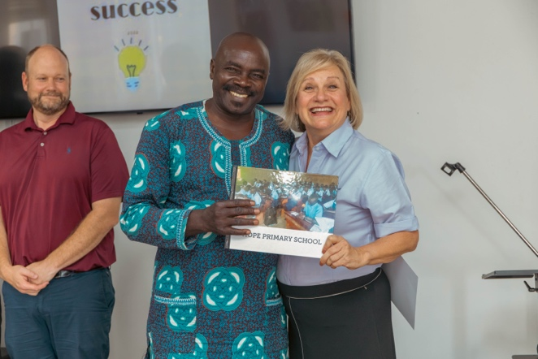 | 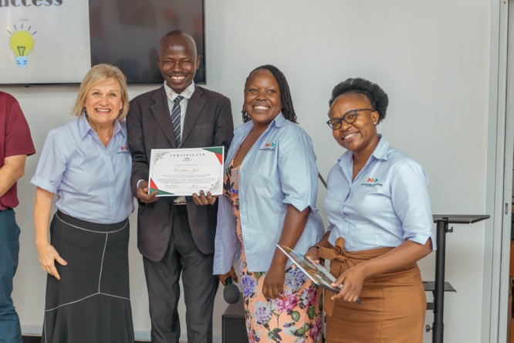
 | 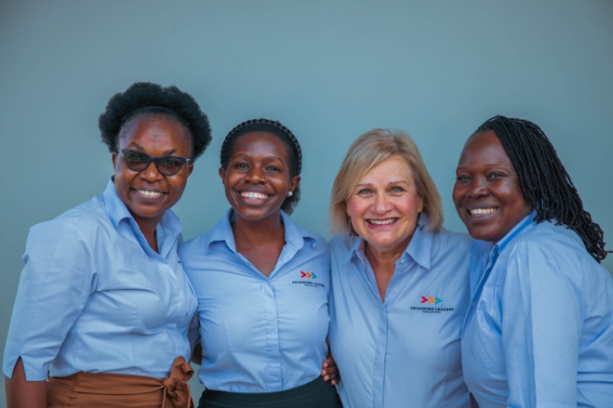

LOOKING FORWARD

In 2024, we plan to work with 6 schools – 2 in Rhino Camp and 3 in Kamuli. We will also wrap up our work with NBACS in Buikwe district.

School | Location | # Teachers | # Learners
New Beginning African School (NBACS) | Buikwe District | 14 | 391
St. Theresa Girls Primary School | Kamuli Municipality | 25 | 1,082
Namisambya SDA Nursery & Primary school | Kamuli Municipality | 13 | 333
Nakulyaku Primary School | Kamuli Municipality | 8 | 210
Harvesters Nursery & Primary School | Rhino Refugee Settlement, Arua | 20 | 513
[Other school TBD from Windle suggestions] | Rhino Refugee Settlement, Arua
Total |  | 80 | 2,529
We feel that we have an understanding with the leadership of these schools and believe that in these places, we will be able to bring much needed support to schools that wouldn’t typically receive it.

In 2024, we want to put more focus on Critical thinking in the classroom especially since we will be working with established schools with trained teachers. We also hope to train more teachers with the intention of having them train others.

We feel privileged to get to work with others in such a collaborative and meaningful way, and we are thankful to all the hands that the support the mission in all ways. We’d like to share special appreciation to the board and the team in the US for all the support especially with rounding up supplies for trainings. We are also thankful to all our donors and supporters!

We look forward to continuing the good work in 2024 and beyond.

